***SHUBHAM GARG***

***9919103057***

***BATCH:F2***

Q1

#include<stdio.h>

int main()

{

int a,i,b,flag=0,flag1=0;

char str1[100]="what";

char str2[100]="whatsoever";

char str3[100]="ever";

char str4[100]="whatever";

char str5[100];

strcat(str1,str3);

printf("%s",str1);

printf("\n\n");

strcpy(str5,str1);

printf("%s",str5);

a=strcmp(str4,str5);

if(a!=0)

{

printf("They are not equal");

}

printf("\n\n");

b=strlen(str1);

printf("The lenght of str1 is %d",b);

printf("\n\n");

for(i=0;i<strlen(str2);i++)

{

if(str2[i]='w')

flag=1;

}

for(i=0;i<strlen(str3);i++)

{

if(str3[i]='w')

flag1=1;

}

if(flag==1 && flag==0 )

printf("yes");

else

printf("no");

}

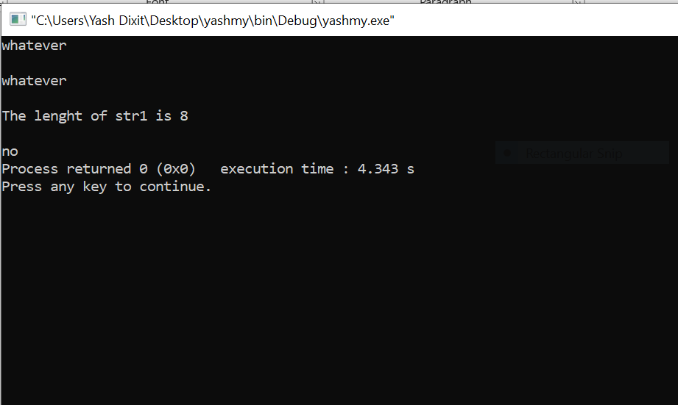

Q2

#include <stdio.h>

#include <stdlib.h>

#include <string.h>

int main()

{

int n,i;

char mystring[100];

printf("enter the string");

gets(mystring);

n=strlen(mystring);

for(i=0;i<n;i++)

{

if(mystring[i]!=' ')

{

mystring[i]=mystring[i] +32;

}

}

for(i=0;i<n;i++)

{

printf("%c",mystring[i]);

}

return 0;

}

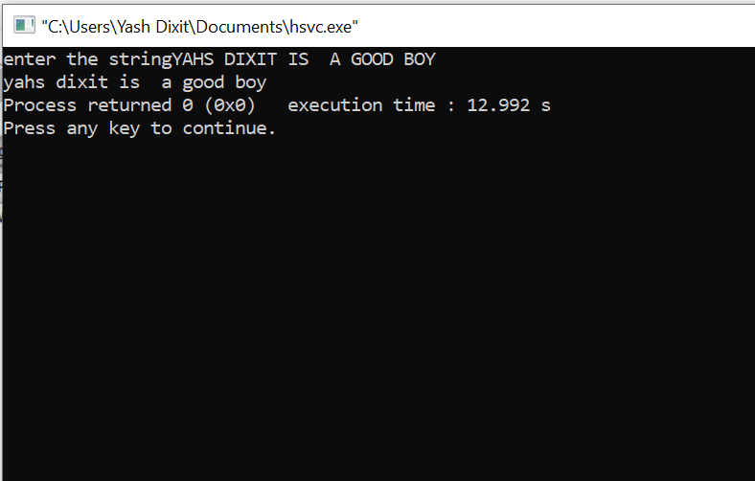

Q3

#include<stdio.h>

int main()

{

int n,i,j,c=0;

char str1[100][100];

char name[100];

printf("Enter the no of names you want to add in the 2 d array");

scanf("%d",&n);

printf("Enter the array of names");

printf("\n");

for(i=0;i<n;i++)

{

scanf("%s",str1[i]);

}

printf("________________________________________");

printf("\n\n");

printf("Enter the name you want to search in the array:");

scanf("%s",name);

for(i=0;i<n;i++)

{

if(strcmp(name,str1[i])==0)

{

c=1;

break;

}

}

if(c==1)

{

printf("The name is present in the 2d array");

}

if(c!=1)

{

printf("The name is not present in the array");

}

}

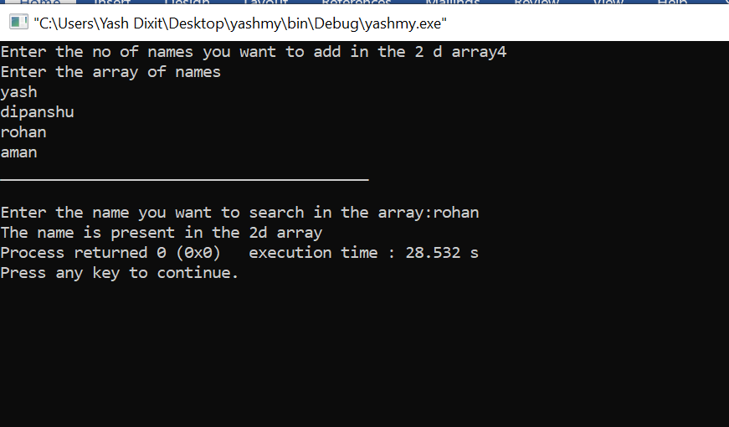

Q4

#include <stdio.h>

#include <stdlib.h>

#include <string.h>

int main()

{

int i,j;

char physics[10][100];

char maths[5][100];

printf("Enter the name of physics performers:");

printf("\n\n");

for(i=0;i<10;i++)

{

scanf("%s",physics[i]);

}

printf("Enter the names of maths performers :");

printf("\n\n");

for(i=0;i<5;i++)

{

scanf("%s",maths[i]);

}

printf("\n\n");

printf("_____________________________________________");

printf("The performers which are common in both physics and maths are namely:");

printf("\n");

for(i=0;i<5;i++)

{

for(j=0;j<10;j++)

{

if(strcmp(physics[j],maths[i])==0)

{

printf("%s",maths[i]);

printf("\n");

}

}

}

return 0;

}

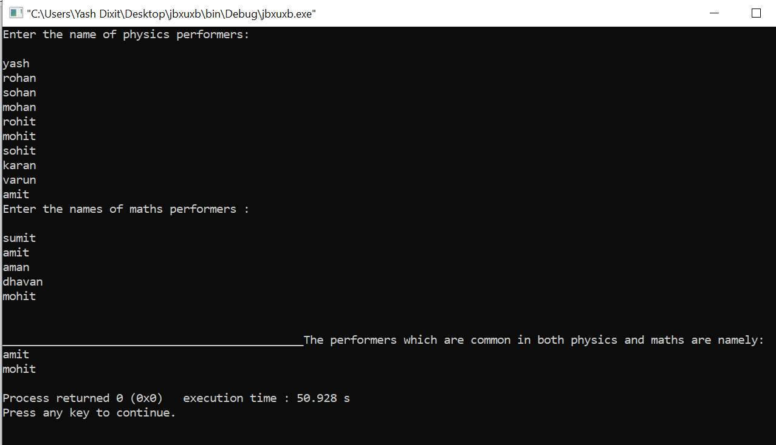

Q5

#include <stdio.h>

#include <stdlib.h>

#include <string.h>

int main()

{

int count;

count=0;

char stringmy[100];

printf("Enter the string");

gets(stringmy);

while(stringmy[count]!='\0')

{

count=count+1;

}

printf("%d",count);

return 0;

}

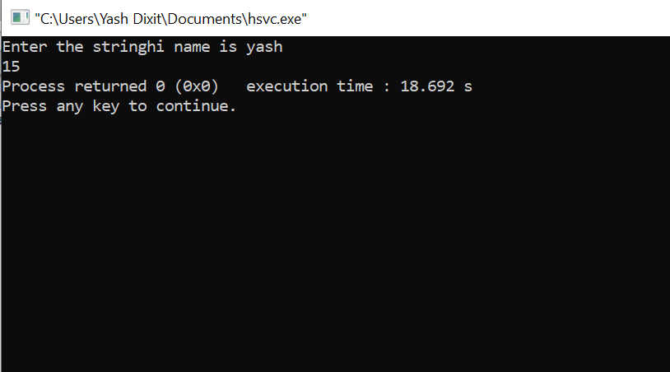

#include <stdio.h>

#include <stdlib.h>

#include <string.h>

int main()

{

int i;

char string1[100];

printf("Enter the string 1");

gets(string1);

char string2[100];

printf("Enter the string 2");

gets(string2);

for(i=0;i<strlen(string1);i++)

{

if(string1[i]>string2[i])

{

printf("string 1 is greater");

break;

}

else if(string1[i]<string2[i])

{

printf("string 2 is greater");

break;

}

else

{

printf("both the strings are equal");

break;

}

}

return 0;

}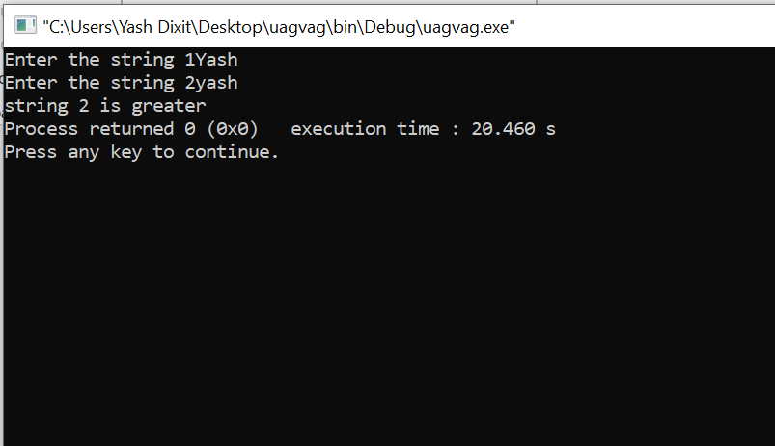

Q7

#include <stdio.h>

int main()

{

char s1[100], s2[100], i;

printf("Enter string s1: ");

scanf("%s",s1);

for(i = 0; s1[i] != '\0'; ++i)

{

s2[i] = s1[i];

}

s2[i] = '\0';

printf("String s2: %s", s2);

return 0;

}

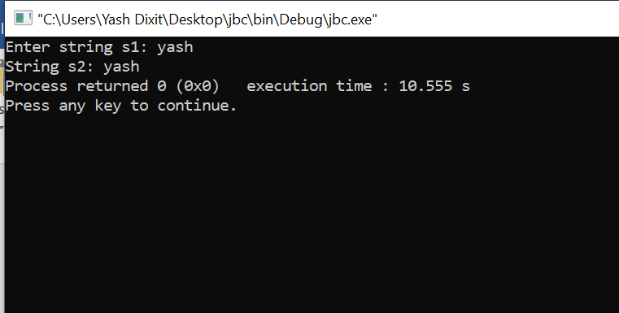

Q9

#include<stdio.h>

int main()

{

int i;

int num[10];

printf("Enter the nos.");

printf("\n");

for(i=0;i<10;i++)

{

scanf("%d",&num[i]);

}

for(i=0;i<10;i++)

{

if(num[i]>=97 && num[i]<=122)

{

printf("%c",num[i]);

printf("\n");

}

}

}